-WARNING- The Transfer Handle® and Security Rails
For Model #’s 1025H,1125H, 2025, 2500/ML, MR, 2025H, 4025H, 6025H, 8025H, 1875M, 1885M, 5075/M, T ,5085/M, T
- DO NOT USE this product or any available optional equipment without first completely reading & understanding these instructions. If you are unable to understand the warnings, cautions or instructions, contact customer service at (800) 854-4687 for assistance before attempting to use this equipment otherwise, injury or damage may occur.
- The Transfer Handle is not intended to prevent an individual from inadvertently rolling out of bed.
- DO NOT USE for confinement or restraint purposes. DO NOT use to transport or move bed.
- ENTRAPMENT MAY OCCUR. Proper patient assessment and monitoring, and proper maintenance and use of equipment is required to reduce the risk of entrapment. Variations in mattress thickness, size or density could increase the risk of entrapment. Remove bed rails and all bed rail mounting brackets prior to installation of the Transfer Handle.
- Although the Transfer Handle model is rated for such use, it may become deformed or broken if excessive force is exerted on the device. The installation should be checked and rechecked periodically for safety.
- After installation, verify the mattress is in firm contact with the Transfer Handle.
- Check that the mattress cannot shift away, immediately discontinue use if this occurs until the situation is corrected.
- The Transfer Handle is designed to accommodate a range of different bed manufacturers. If the device does not easily attach to the bed per the instructions or interferes with the sub-frame, or the mattress does not firmly make contact with the Transfer Handle – DO NOT USE. Contact customer service at (800) 854-4687
- Visit the FDA website at http://www.fda.gov to learn about the risks of entrapment.

IMPROPER INSTALLATION CREATES A RISK OF ENTRAPMENT: IN ORDER TO AVOID ENTRAPMENT, THE EDGE OF THE MATTRESS MUST REMAIN WITHIN 2” OF THE TRANSFER HANDLE.

Potential Zones of Entrapment
Zone 1: Within the Rail
Zone 2: Under the Rail, Between the Rail Supports or Next to a Single Rail Support
Zone 3: Between the Rail and the Mattress
Zone 4: Under the Rail, at the Ends of the Rail
Zone 5: Between Split Bed Rails
Zone 6: Between the End of the Rail and the Side Edge of the Head or Foot Board
Zone 7: Between the Head or Foot Board and the Mattress End
Dimensional Limit Recommendations
Zone 1: Within the Rail 4 3/4inches
Zone 2: Under the Rail, Between the Rail Supports
or Next to a Single Rail Support 4 3/4inches
Zone 3: Between the Rail and the Mattress 4 3/4inches
Zone 4: Under the Rail, at the Ends of the Rail 2 3/8 inches

See Opposite Side

Zone 1 - Entrapment within the rail  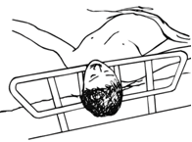 | Zone 2 - Entrapment under the rail, between the rail supports or next to a single rail support  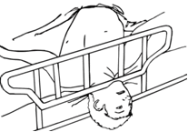
Zone 3 - Entrapment between the rail and mattress  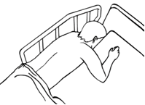 | Zone 4 - Entrapment under the rail, at the end of the rail  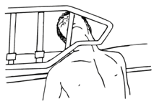
Zone 5 - Entrapment between split bed rails  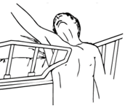 | Zone 6 - Entrapment between the end of the rail and the side edge of the head or foot board  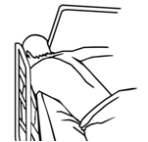
Zone 7 - Entrapment between head or foot board and the mattress end  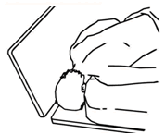 | These guidelines were developed by the FDA for  Bed Rails to help prevent  entrapment. It is important information to be aware of.

